***PROJECT REPORT TEMPLATE***

1. INTRODUCTION

* 1. Overview

A brief description about your project

* 1. Purpose

The use of this project. What can be achieved using this.

2. PROBLEM DEFINITION AND DESIGN THINKING

2.2 Empathy Map

Paste the empathy m 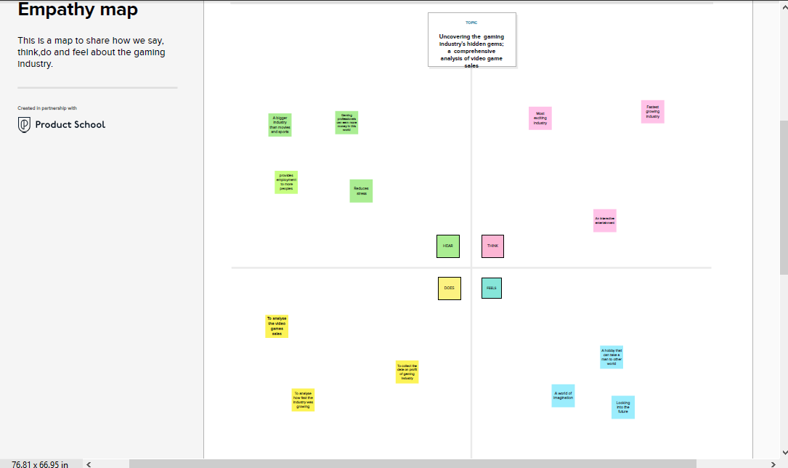ap screenshot

2.3 Ideation and Brainstorming

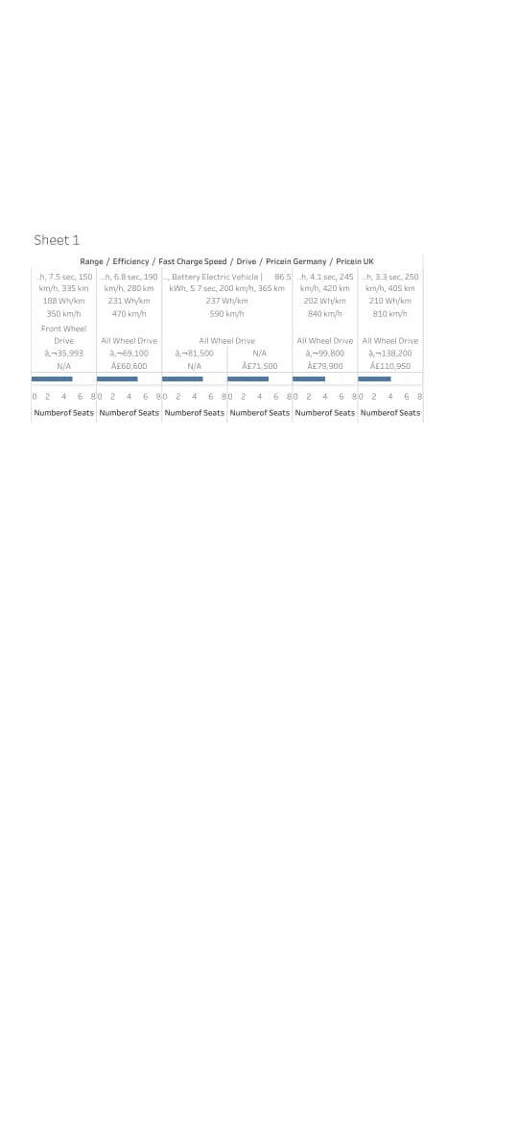

* No fuel required so you save money on gas
* Environmental friendly as they do not emit pollutants
* Lower maintenance due to an efficient electric

Motor

Disadvantages

* Battery lifespan concerns
* Charging times
* Charging infrastructure worries
* Low top speeds

Applications

* Electricity is the thing. There are no whirring and grinding gears with their numerous levers to confuse.

Conclusion

Traditional motor vehicles , electric vehicles **do not** run on diesel of gasoline. Electric vehicles, therefore do not emit air pollutants.